Architectural Overview of the Sandbox Environment
This section describes a concrete, implementable architecture for the Agentic AI Risk-Aware Credit Decisioning Sandbox. The design assumes that agentic credit decision flows are built and maintained through a no-code/low-code orchestration layer, while the surrounding platform provides data, governance, role-based access control, and execution controls.
The architecture comprises three main pillars:
- Sandbox Platform: Manages scenarios, runs, decisions, and governance.
- Agentic Orchestration Layer: Enables visual design and execution of agentic flows.
- Agent Tooling and Services: Provides deterministic, callable services for affordability, policy, and risk evaluation.
At a logical level, the sandbox functions as a closed ecosystem where:
- Product and risk teams define scenarios and synthetic credit portfolios.
- Flow designers visually configure agentic decision flows using tools like Langflow.
- The sandbox executes these flows across various scenarios, utilizing synthetic or anonymized data.
- All decisions, traces, and metrics are meticulously captured for subsequent replay and analysis.⁴

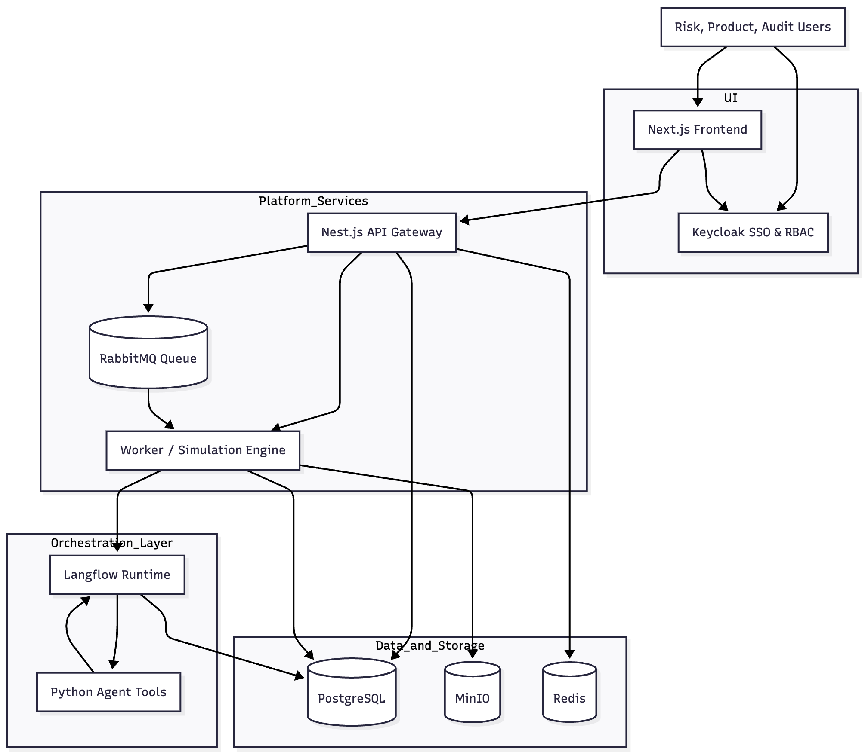

Technology Stack
To keep the system buildable and maintainable, the stack is deliberately conservative:
- Frontend: Utilizing Next.js and TypeScript, handles authentication and authorization via a Keycloak JS adapter.
- Backend / Platform: Services are built with Nest.js, leveraging REST APIs, a Keycloak adapter, and RabbitMQ for robust functionality.
- No-code / Low-code orchestration: Provided by a Langflow service, implemented with Python, FastAPI, and a React UI.
- Agent tool services: Comprise Python FastAPI micro-services for affordability, policy, and risk evaluation, each exposing HTTP APIs.
- Messaging / Asynchronous execution: Managed by RabbitMQ, handling run jobs and isolated simulation workloads.
- Storage and observability: PostgreSQL stores relational data for scenarios, runs, decisions, and flow metadata; MinIO is used for full execution traces and logs; and Redis provides caching and simple rate limiting.
- Identity and RBAC: Handled by Keycloak, acting as the identity provider and role manager.
All services communicate over internal TLS-protected HTTP or AMQP within a secured subnet. This robust architectural design facilitates containerized deployment, enabling independent updates and seamless scalability across various cloud environments ⁵.

No-Code / Low-Code Orchestration Layer
The no-code / low-code capability is provided by Langflow, which is deployed as a separate internal service.

Flow Design
Flow designers construct agentic credit decision workflows within the Langflow UI, exemplified by applications such as mortgage decision flows and personal loan agentic flows. Each workflow is structured as a directed graph, comprising distinct node types:
- Input nodes: Receive application and scenario data in JSON format from the Risk-Aware Credit Decisioning Sandbox.
- Tool nodes: Invoke predefined internal HTTP services (e.g., Affordability API, Policy Check API, Risk Tagging API) and, optionally, external services.
- LLM/Agent nodes: Process and interpret results, synthesize diverse signals, and produce explanatory outputs.
- Control nodes: Manage workflow execution paths dynamically based on defined flags.
- Output nodes: Transmit a structured JSON object to RA-CDS, encapsulating the decision, rationale, pertinent flags (e.g., requires_human_review, policy_edge_case), and an internal_trace detailing the step-by-step execution.
Workflows are versioned and persist within Langflow. The RA-CDS platform maintains references solely to workflow identifiers and versions, eschewing duplication of the internal graph definitions.

Flow Registry and Publication
To maintain governance and prevent uncontrolled growth of decision flows, the RA-CDS backend maintains a flow registry in PostgreSQL. Each entry contains:
- id – internal UUID
- langflow_flow_id – identifier used by Langflow
- name – e.g., Mortgage_Agentic_V1
- product_type – mortgage, personal loan, credit card, etc.
- status – draft, active, deprecated
- created_by, created_at
- last_published_at
Publication Controls
- Only users with the Keycloak role flow-publisher may activate a flow.
- Execution runs may only use flows with status = active.
- Deprecated flows remain available for audit and replay but are blocked from new use.
A Flow Catalog in the Next.js interface provides a consolidated view of all flows, their status, and associated product mappings. This supports transparency, lifecycle management, and consistent operational governance across the decisioning environment.

Frontend Layer (Next.js)
The frontend, implemented in Next.js, provides four core interfaces that support scenario configuration, flow governance, simulation execution, and detailed trace analysis. All screens enforce user authentication through the Keycloak, and role-based capabilities are validated in both the UI and backend.

1. Scenario Builder
This screen allows users to define and configure simulation scenarios. Key parameters include:
- product type (e.g., mortgage, credit card)
- base distributions for synthetic applications (income, LTV ranges)
- drift or stress parameters (e.g., LTV upward shift, interest-rate shock)
- number of applications generated per run
Scenario definitions persisted through POST and PUT operations to /api/scenarios.

2. Flow Catalog
The Flow Catalog exposes all registered flows maintained by the RA-CDS flow registry. For each flow, the interface displays:
- the linked langflow_flow_id
- current lifecycle status (draft, active, deprecated)
- associated product types
Users with the flow-publisher role may publish or deprecate flows; others have read-only access.

3. Run Management
Users initiate simulation runs by selecting:
- a scenario
- an active flow
- run parameters (baseline, drifted, or stressed mode)
The interface provides status updates (queued, running, completed) and supports pagination through historical runs with summary statistics.

4. Decision and Trace Viewer
For each completed run, users can:
- view application-level decisions (approve, decline, refer)
- inspect the application snapshot and explanation strings
- retrieve detailed Langflow execution traces through time-limited signed URLs to MinIO
- visualize the agent and tool execution sequence
- Access to detailed traces is restricted to users with the appropriate Keycloak roles.

Backend / Platform Layer (Nest.js)
The backend, built using Nest.js, exposes governance, scenario, and run-management APIs. Major endpoints include:
- /api/scenarios — CRUD operations for scenario definitions
- /api/flows — exposure of registry entries and publication controls
- /api/runs — run creation and status retrieval
- /api/decisions — decision summaries
- /api/decisions/:id/trace — generation of time-limited MinIO URLs for trace retrieval

Key Responsibilities

RBAC Enforcement
All requests are authenticated using Keycloak-issued JWTs. Authorization checks validate user roles such as:
- sandbox-admin
- sandbox-risk
- sandbox-audit
- sandbox-viewer
- flow-designer, flow-publisher

Flow Validation
Upon initiation of a run, the backend verifies that:
- the flow exists in the registry
- its status is active
- the requesting user is authorized to execute the flow for the selected product

Run Dispatch
When a run is created, the backend writes a record to PostgreSQL and publishes a job to RabbitMQ with:
{ "run_id": "uuid", "scenario_id": "uuid", "flow_id": "uuid" }

Trace Mediation
To preserve security and governance, the backend never exposes raw MinIO keys. Instead, it generates signed URLs scoped to the user's permissions and with time-limited validity.

Worker / Simulation Service
The Worker is a Node.js (or Nest.js) service that consumes jobs from RabbitMQ and executes simulations at scale.

Execution Steps for Each Run
- Scenario Loading
Retrieve scenario configuration from PostgreSQL.
- Synthetic Data Generation
Produce applications based on configured distributions, including drifted or stressed variants when applicable.
- Per-Application Execution
For each generated application:
  - create the combined payload:
{ "application": { ... }, "scenario": { ... } }
  - invoke the selected Langflow flow via
POST /api/v1/flows/{langflow_flow_id}/run
  - receive structured outputs containing:
    - decision
    - reasons
    - flags
    - internal_trace
  - write decision summaries to PostgreSQL
  - upload the internal_trace JSON to MinIO under:
traces/{run_id}/{decision_id}.json
- Run Finalization
After all applications are processed, the run is marked completed in PostgreSQL.

Agent Tool Services
Agent tool services are deterministic FastAPI microservices implemented in Python. They encapsulate domain logic that is consumed by Langflow flows via HTTP tool nodes.

Representative Services

1. Affordability Service
- Endpoint: POST /affordability
- Input: income, existing obligations, loan parameters
- Output: DTI metrics, stressed DTI, affordability category

2. Policy Check Service
- Endpoint: POST /policy/check
- Input: application and product attributes
- Output: policy hits (e.g., LTV threshold violations, restricted regions)

3. Risk Tagging Service
- Endpoint: POST /risk/tag
- Input: decision proposal, application, scenario data
- Output: tags such as “borderline affordability” or “high LTV but mitigated”
Embedding domain logic in lightweight services ensures transparency, testability, and repeatability. Langflow uses these tools as structured, deterministic signals during agentic decision-making, reducing reliance on opaque LLM reasoning.

Data and Storage Architecture
The RA-CDS platform employs a multi-tiered data and storage architecture designed to ensure durability, auditability, and high-performance access during large-scale simulation and decisioning workloads. The architecture consolidates structured relational data in PostgreSQL, unstructured and semi-structured artifacts in MinIO (S3-compatible object storage), and transient performance-critical state in Redis.

PostgreSQL (Relational Data Layer)
PostgreSQL serves as the authoritative system of record for all structured artefacts generated and consumed by the sandbox. Core tables include:
- scenarios: Encodes scenario definitions, including product parameters, distributional assumptions, and configuration of drift or stress components.
- flows: Serves as the registry for all agentic decision flows, maintaining mappings to Langflow identifiers, flow status (active/disabled), ownership, and publication metadata.
- runs: Captures every simulation execution instance, including scenario–flow associations, execution status, lifecycle timestamps, and audit references.
- applications: Stores optionally persisted synthetic application snapshots generated per run, enabling reproducibility and downstream analysis.
- decisions: Represents the canonical record of decision outcomes, including decision codes, explanatory reasons, flags, and trace identifiers linking to object-store artifacts.
- metrics_snapshots: Holds aggregated performance and risk metrics per run, enabling longitudinal monitoring of agentic flow behavior.
This schema provides strong referential integrity across simulation artefacts, supports multi-tenant separation, and enables deterministic replay of decision episodes for audit and validation.

MinIO (Object Storage Layer)
MinIO provides scalable, S3-compatible object storage for unstructured data that cannot be efficiently expressed in relational form.
- sandbox-traces bucket: Stores complete internal_trace artefacts emitted by Langflow for each decision episode, including reasoning chains, tool-invocation metadata, and intermediate agent states.
- sandbox-logs bucket (optional): Retains operational logs, worker-side diagnostics, and auxiliary artifacts useful for debugging and observability.
This separation ensures that high-volume trace data remains cost-efficient and query-optimized, while PostgreSQL retains only lightweight references.

Redis (High-Performance Caching Layer)
Redis is utilized selectively to enhance performance and user experience:
- Caching scenario definitions and flow metadata to minimize database round-trips.
- Maintaining short-term run summaries to support low-latency UI dashboards.
- Enforcing rate-limits on sensitive operations, if required for governance or system stability.

Data Isolation and Governance
All data stores—relational tables and object buckets—are explicitly scoped to the sandbox environment. No production customer data is ingested. If production-derived datasets are ever incorporated for model testing, they must be fully de-identified, access-controlled, and governed under separate institutional data-handling policies to maintain compliance with financial-services regulatory expectations.

Identity, RBAC, and Governance
Identity management and role-based access control (RBAC) are centralized through Keycloak, which provides authentication, authorization, and governance across the RA-CDS ecosystem. A dedicated Keycloak realm (sandbox) isolates all resources and aligns identity boundaries with sandbox-level data governance requirements.

Registered Clients
- sandbox-ui (public) – consumed by the Next.js front-end.
- sandbox-api (confidential) – consumed by the Nest.js backend, requiring client secrets and strict token policies.
- langflow-ui (public or confidential) – used by Langflow and integrated with RA-CDS for single-sign-on (SSO).

Role Model
Keycloak roles enforce granular, principle-of-least-privilege access:
- sandbox-admin – unrestricted access, including user, role, and flow governance capabilities.
- sandbox-risk – authorised to define scenarios, execute flows, and inspect detailed decisions and trace artefacts.
- sandbox-audit – read-only access to all artifacts including traces, enabling regulatory or compliance review.
- sandbox-viewer – limited to summary-level views without access to sensitive trace-level reasoning.
- flow-designer – permitted to authenticate into Langflow to create or edit agentic flows.
- flow-publisher – authorised to publish Langflow designs into the RA-CDS flow registry.
Every front-end request to Nest.js includes a Keycloak-issued JWT; the backend verifies signature, expiry, and role claims before processing. By configuring Langflow to use the same Keycloak realm, designers and risk analysts gain seamless SSO across the RA-CDS platform and the agentic flow-authoring environment.

Execution Sequence: Agentic Flow for a Single Credit Application
The following sequence captures a complete decisioning episode executed by RA-CDS using a Langflow-based agentic workflow, illustrating the interplay between the UI, API, worker services, and the agentic runtime.
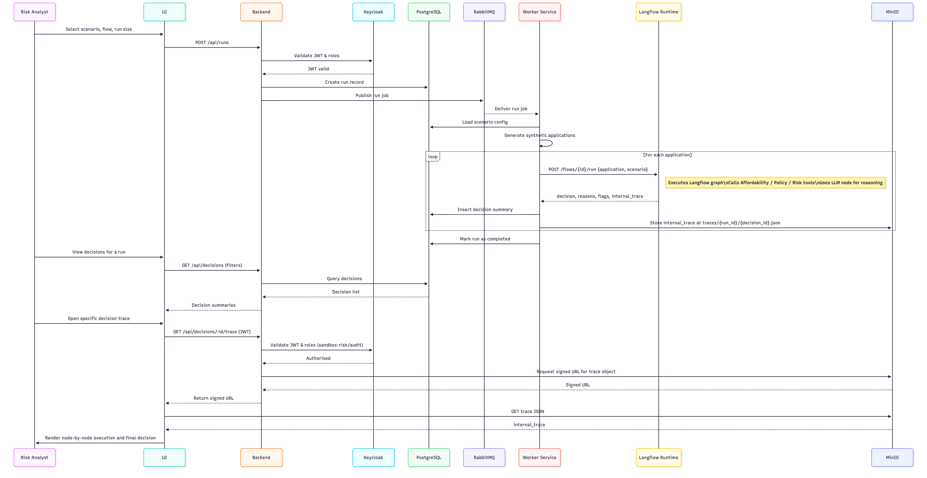

AWS-Based Deployment Architecture of the Agentic Credit Decisioning Sandbox

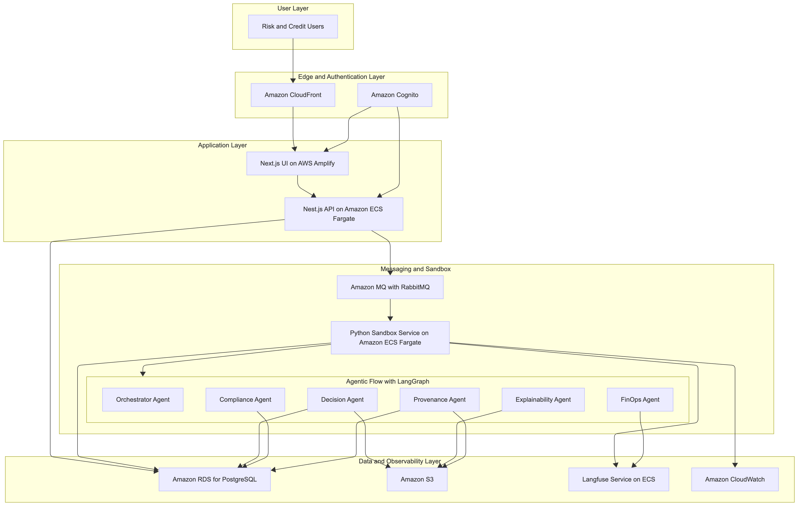
The Agentic AI Risk-Aware Credit Decisioning Sandbox is deployed on Amazon Web Services (AWS) using a layered, modular, and event-driven architecture designed to support reproducibility, auditability, and operational governance under regulated financial conditions. The architecture integrates cloud-native identity management, containerized microservices, asynchronous orchestration, and scalable storage services to ensure consistent execution of multi-agent decision processes. This section details the physical deployment model, agent distribution, and service interactions across the AWS environment.

Edge, Identity, and Application Layer
The entry point to the sandbox is a web interface served through Amazon CloudFront, which provides global edge delivery and TLS termination. The analyst-facing user interface is implemented using Next.js and deployed on AWS Amplify Hosting, enabling version-controlled continuous deployment and seamless integration with AWS identity services.
User authentication and authorization are handled by Amazon Cognito, which replaces the on-premises Keycloak identity provider. Cognito user pools manage credentials and group-based access controls; groups (e.g., sandbox-runner, sandbox-auditor, sandbox-admin) are encoded in JSON Web Tokens (JWTs). These JWTs are consumed by downstream application components to enforce fine-grained role-based access control (RBAC).
The sandbox control plane is implemented as a microservice in Nest.js and deployed to Amazon Elastic Container Service (ECS) Fargate. The service exposes REST endpoints for scenario creation, run instantiation, decision retrieval, and audit artifact access. The control plane validates Cognito-issued JWTs and writes metadata including run definitions, scenario parameters, and decision summaries to Amazon Relational Database Service (RDS) for PostgreSQL.

Messaging, Execution, and Agentic Runtime Layer
The asynchronous execution fabric of the sandbox is built using Amazon MQ configured with the RabbitMQ engine, ensuring compatibility with established event-driven processing patterns. When analysts initiate a simulation or decision batch through the control plane, messages describing the run are published to dedicated queues within Amazon MQ.
A containerized Python Sandbox Runtime also deployed on ECS Fargate consumes these messages from Amazon MQ. For each job, it constructs an episode-level execution context, loads application data and scenario metadata, and triggers a deterministic multi-agent decision workflow implemented using LangGraph, an agentic control framework that models reasoning as a directed acyclic computational graph.
Within the runtime, the following agents operate as coordinated components:

Orchestrator Agent
Manages the end-to-end decision episode by enforcing deterministic ordering of agent execution, seeding stochastic components for reproducibility, and aggregating outputs from all downstream agents. It is responsible for final arbitration and ensuring compliance constraints are respected.

Decision Agent
Generates the initial decision proposal using contextual application attributes and scenario-specific logic. Domain tools such as affordability estimation and scenario tagging are implemented either as local Python modules or lightweight FastAPI microservices, wrapped as LangChain tools for consistent invocation.

Compliance Agent
Interfaces with a structured policy evaluation layer to assess whether proposed actions satisfy regulatory and internal policy requirements. Policies are encoded in machine-readable formats and accessed through a small policy service. The agent returns structured proofs, required obligations, and categorical compliance decisions.

Explainability Agent
Produces structured natural-language rationales and counterfactual narratives for decisions that require explanation. The agent executes bounded large-language-model (LLM) routines using LangChain templates and ensures alignment with the evidence schema required by the provenance pipeline.

Provenance Agent
Constructs a detailed evidence graph for each decision episode, incorporating input attributes, compliance signals, policy proofs, explainability outputs, and FinOps measurements. Evidence objects are written to Amazon S3, and cryptographic seal hashes are computed and persisted in Amazon RDS, enabling external verification and replay.

FinOps Agent
Collects execution-time metrics including latency, compute usage, and cost estimates through LangChain instrumentation and exposes them for system-level performance evaluation. Operational signals are exported to Amazon CloudWatch and Langfuse for observability and post-hoc analysis.
All agents emit fine-grained traces, tool calls, and performance metrics to Langfuse, deployed as a separate ECS service. Langfuse provides unified observability across the entire agentic pipeline, enabling auditability, debugging, and continuous-integration style validation of agentic behavior.

Data Management, Artifact Storage, and Observability Layer
The sandbox maintains a strict separation between metadata, decision outputs, and audit artifacts. Amazon RDS for PostgreSQL serves as the authoritative metadata layer for runs, decision summaries, policy proofs, and sealed governance records. All unstructured artifacts including provenance graphs, explanation bundles, and scenario-level evaluation files are stored in Amazon S3 with versioning enabled.
Operational telemetry is collected through Amazon CloudWatch, which aggregates logs and metrics from ECS tasks, Amazon MQ, and RDS. Complementing CloudWatch, Langfuse captures trace-level introspection for each agentic execution step, including prompt inputs, outputs, token counts, and tool-level interactions.

Architectural Characteristics
The AWS deployment exhibits several properties essential for research and regulatory compliance:
- Scalability: ECS Fargate and Amazon MQ scale automatically with workload intensity, enabling high-volume simulations.
- Determinism: LangGraph-defined DAGs ensure that multi-agent execution paths remain reproducible across runs, an essential feature for auditing.
- Auditability: S3-stored sealed artifacts and RDS-stored governance metadata form a complete evidence trail.
- Isolation: Fargate tasks run in isolated, ephemeral compute environments, reducing cross-run interference.
- Security: Cognito-based RBAC, VPC isolation, and IAM-governed S3 policies provide a secure execution context.
- Observability: Langfuse and CloudWatch deliver comprehensive diagnostic capability across the multi-agent pipeline.

